Task 1: Create an architecture Diagram
CTU-20232150 Resource Group
Create Users and Assign Users to Groups
Role Based Access Control and SAS Permissions
Network Security Groups and Its rules
Containers
Budget Alerts and Cost Management
Azure Monitor (Metrics, Logs)
Log Analytics Workspace
Virtual Networks (Subnets)
Storage Accounts
Virtual Machines

Task 2: Documenting my whole Azure Environment.
Section 1
- We have our Resource Group named CTU-20232150-RG it is the one that has all the other resources under it. It is under the subscription Azure for Students and it has 16 deployments under it of which two of them failed to deploy.
- Virtual Network – This virtual network has 3 subnets in it namely : default, snetdb and webapp. Picture 1 has the full details of the virtual network.
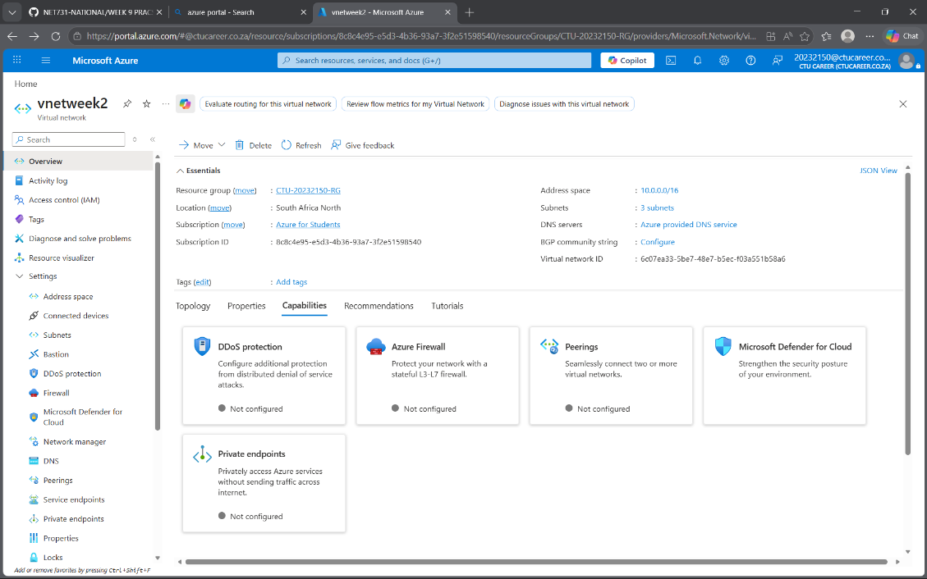Picture 1
- Virtual Machine – Picture 2 and 3 has all the details of the virtual machine
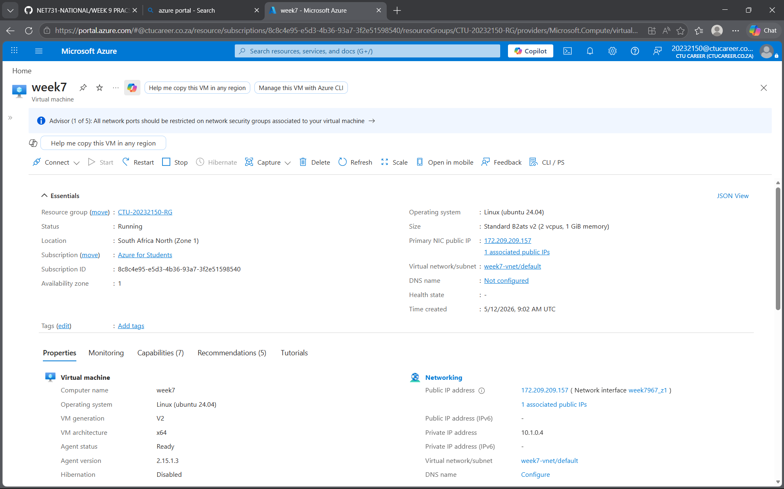Picture 2
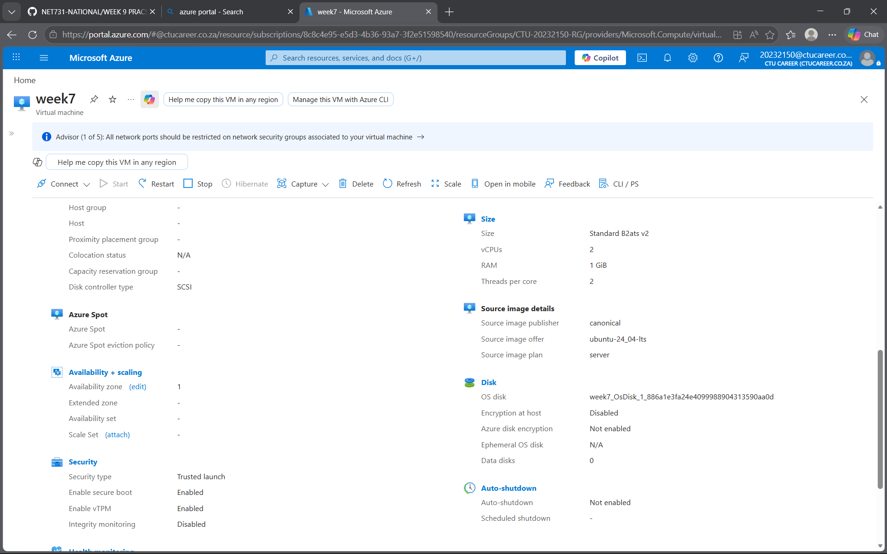
Picture 4
Section 2
- Network security group configurations in Picture 5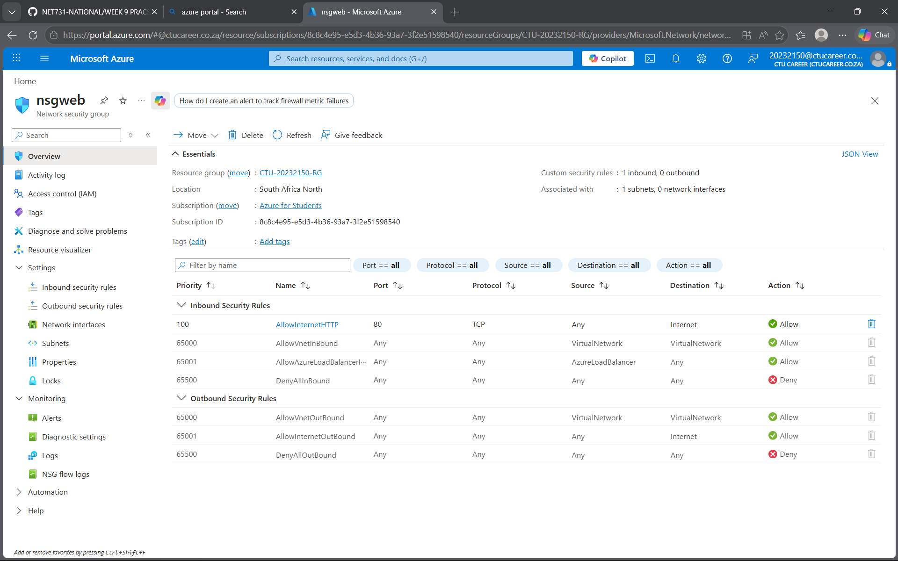
- Storage Account Configurations
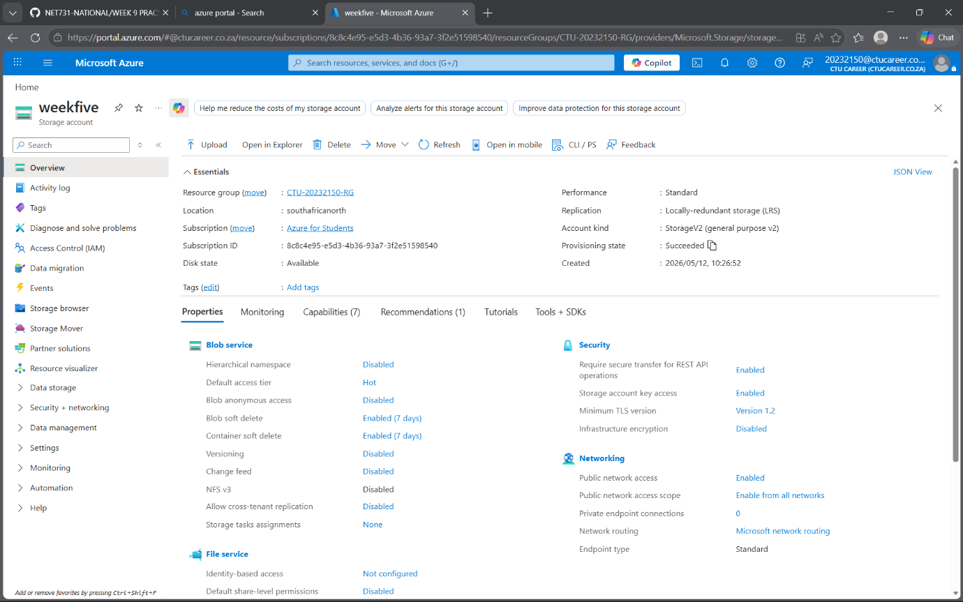
- Containers
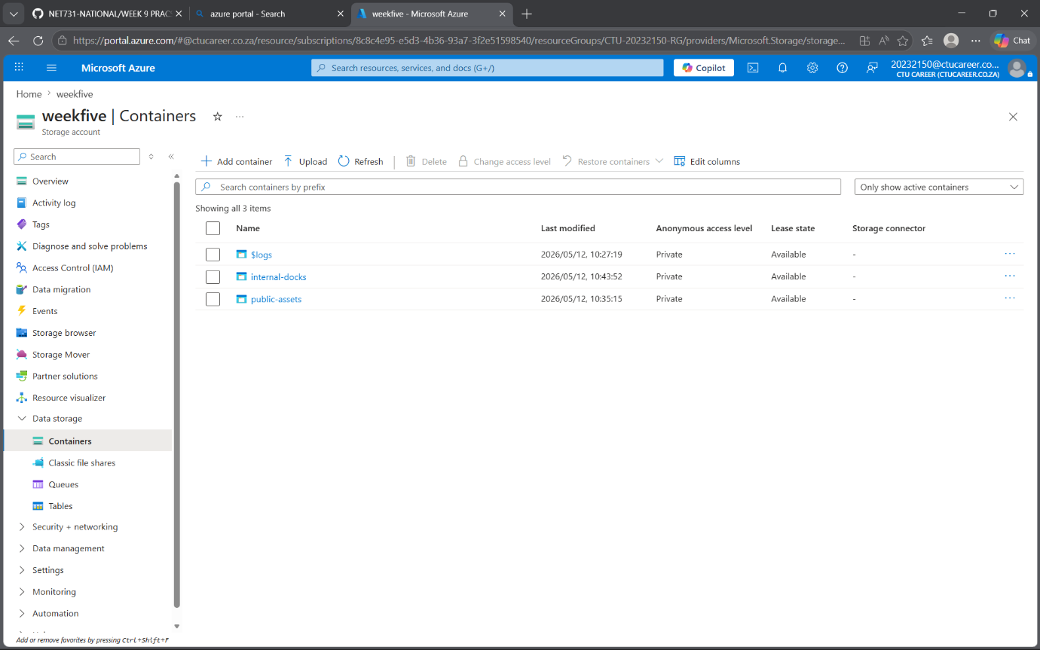
Section 3
- Metrics
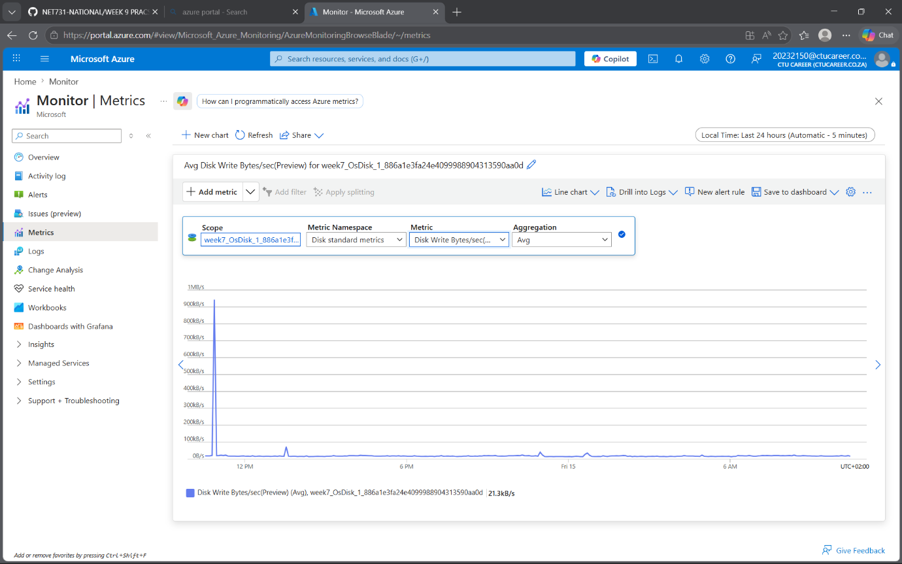
- Network metrics
